

**The Superior University, Lahore**



**TASK 3 (FALL 2024)**

|  |  |  |  |  |  |  |  |  |
| --- | --- | --- | --- | --- | --- | --- | --- | --- |
| Course Title: | PAI | | | | Course Code: | CPR601260 | Credit Hours: | 4 |
| Instructor: | SIR RASIKH ALI | | | | Program Name: | BSAI | | |
| Semester: | 4th | Batch: | F23 | Section: | BSAIM-4C | Date: | 5 March, 2025 | |
| Time Allowed: |  | | | | Maximum Marks: | |  | |
| Student’s Name: | ZAID MEHMOOD | | | | Reg. No. | SU92-BSAIM-F23-128 | | |
| Lab3-Task | | | | | | | | |

**LAB 3 TASK:-**

***Water jug with DFS***

**Code:-**

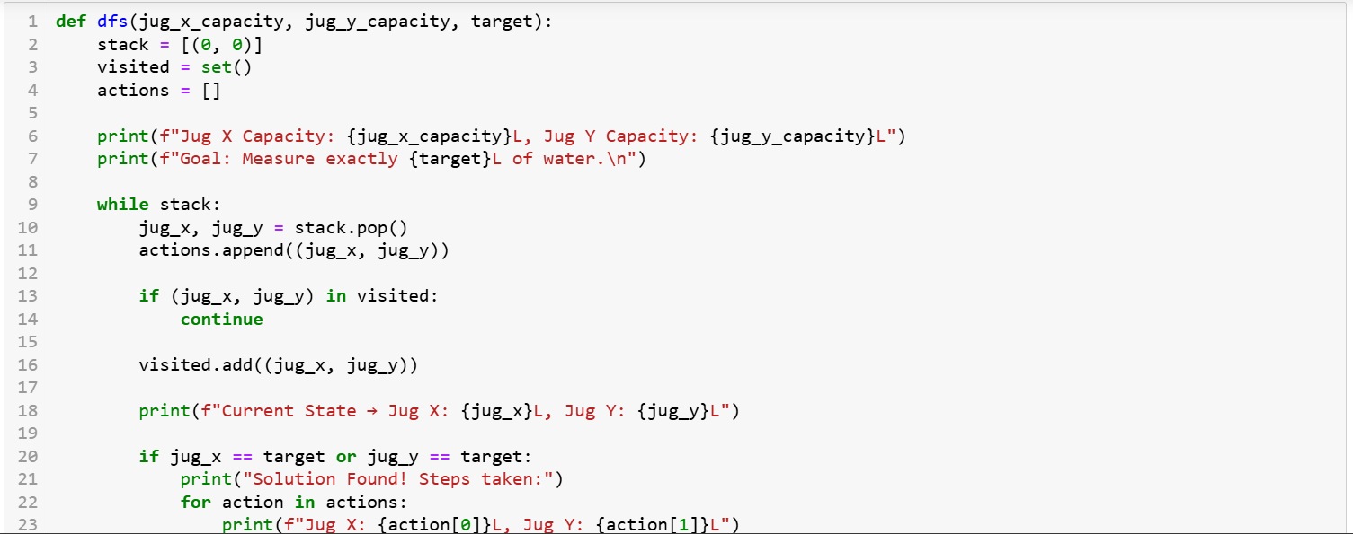

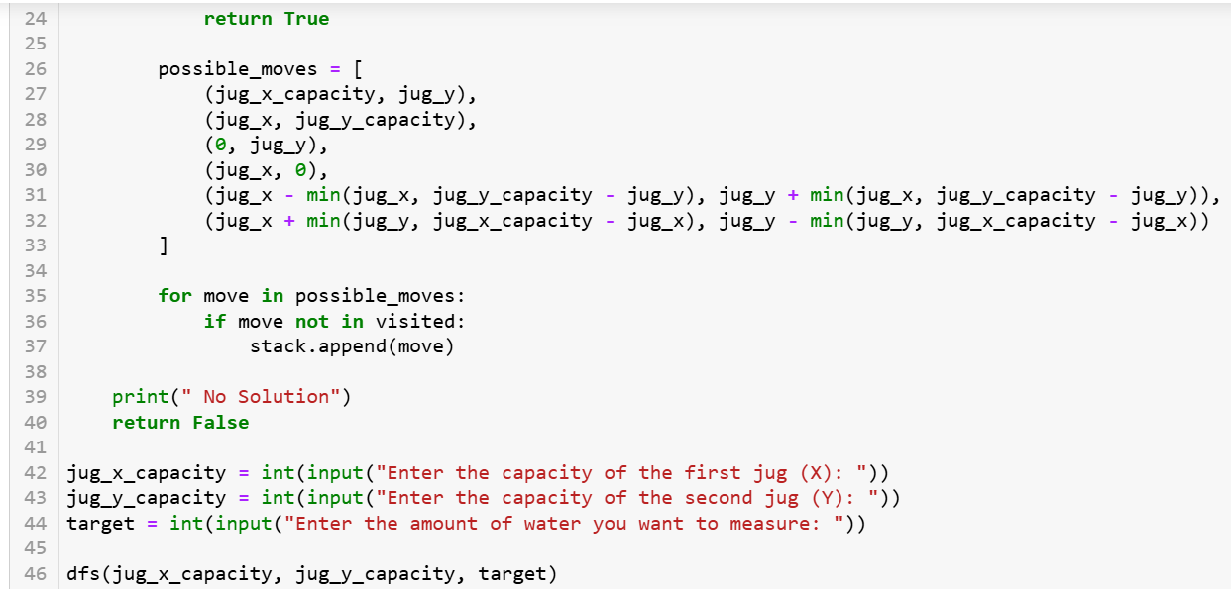

**Output:**



